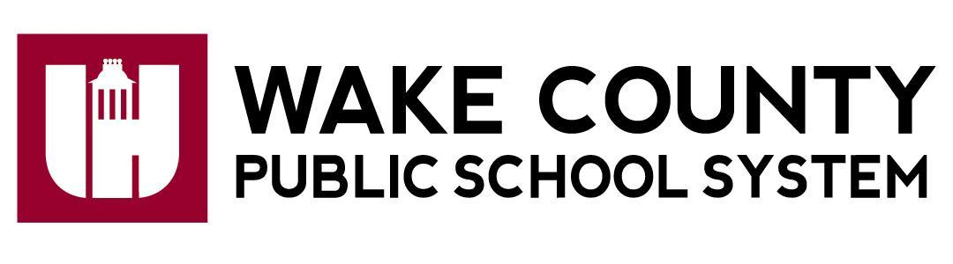

**Neuse River Middle School**

**Bonnie Mwanda, Principal**

2700 Old Milburnie Rd

Raleigh, NC 27604

tel: 919-266-8500

Fax: 919-589-6240

http://www.neuseriverms.net

December 3, 2023

Dear Parent/Guardian:

I am writing this letter to notify you that Neuse River Middle School has been dually designated as both a North Carolina Low-Performing school and a federally identified Targeted Support & Improvement Additional Targeted Support (TSI-AT) school by the North Carolina State Board of Education.

As defined in G.S. 115C-105.37: “The State Board of Education shall identify low-performing schools on an annual basis. Low-performing schools are those that earn an overall school performance grade of D or F and a school growth score of "met expected growth" or "not met expected growth" as defined by G.S. 115C-83.15.” Legislation (G.S. §115C-83.15) passed during the 2013 long North Carolina General Assembly session provides parents with an additional measure of school performance in the form of School Performance Grades. Beginning with the 2013–14 school year, the annual North Carolina School Report Cards display a letter grade of A, B, C, D, or F for each school in the state.

School Performance Grades are based 80 percent on our school’s achievement score (student proficiency) and 20 percent on students’ academic growth. At Neuse River Middle School, our achievement score for the 2022-2023 school year is based on how well our students performed on Grades 6–8 Mathematics, Grades 6–8 English Language Arts/Reading, Grades 8 Science, NC Math 1. Neuse River Middle School received a School Performance Grade of D and a growth designation of Met for the 2022–2023 school year.

In addition, per the Every Student Succeeds Act (ESSA) Section 1111(d)(2), schools receive the federal identification of TSI-AT in North Carolina by having one or more of the following subgroups receive a subgroup performance grade score at or below the lowest 5% of schools across the state during the 2021- 2022 academic year; and being identified as a consistently underperforming subgroup in 2019-2020. Subgroup performance scores are provided for the following subgroups of students: (1) Students with Disabilities, (2) Economically Disadvantaged, (3) Black, (4) White, (5) Hispanic, (6) Asian-Pacific Islander, (7) Multi-racial, and (8) English Learners.

As a dually designated TSI-AT and NC low-performing school,Neuse River Middle School is required to develop a comprehensive improvement plan that specifically addresses how the school will improve student achievement. The plan will also include strategies that our district or charter will employ to support Neuse River Middle School improvement efforts. The comprehensive improvement plan will address the following areas:

* Classroom Management
* Standards-aligned Instruction
* Professional Learning Communities (PLCs)
* Instructional Leadership
* Recruitment & Retention of Effective Teachers
* Support for Grade-to-Grade Transitions
* Implementation of a Tiered Instructional System
* Data-Driven Decision Making
* Student Support Services
* Family and Community Engagement

We have set the following goals for Insert name of the school this year:

By the end of the 23-24 school year, Neuse River students in all subgroups will exceed growth as measured by the North Carolina End of Grade test.

Here are some strategies that we will be implementing to improve student outcomes:

* Partnership with NTN to strengthen Math instruction and ensure lessons are aligned to North Carolina standards
* Professional learning provided by Marzano Resources to provide teachers with skills and knowledge necessary to engage all students
* Student completion of weekly iReady lessons to fill in gaps in reading and math and move them towards proficiency.

Also, parent engagement is at the heart of our school improvement efforts. Here are some ways we can work together:

* Ensure that both you and your child know the academic expectations set for your child this school year. A list of learning objectives in student-friendly language is available from your student’s teacher(s).
* Call 919-266-8500 and speak with your child’s grade level counselor or administrator if you have questions or concerns about your student or to set up an appointment to meet with a school staff member who will be working with your child.
* Make sure that your child is prepared and attends school each day.
* Monitor your child’s homework.
* Monitor the progress your child is making and attend meetings with your child’s teacher(s).
* Keep track of our website and social media sites [insert links].
* Volunteer.
* Join the PTSA or Arts Boosters

Additionally, listed below are a few resources available to help:

* Graduation requirements: www.ncpublicschools.org/gradrequirements/
* K-12 standards in academic subjects: www.ncpublicschools.org/curriculum/
* State student achievement test results: www.ncpublicschools.org/accountability/
* N.C. School Report Cards: https://ncreportcards.ondemand.sas.com/src

We are committed to improving student performance. It is important to remember that just as no single score or grade tells the whole story of a student, neither does it tell you everything about a school's performance or the opportunities that our school provides. The intent of receiving these designations is to improve educational outcomes for all students, close achievement gaps, increase equity, and improve the quality of instruction. We’re excited about this school year and are working to make it a success for your child. Already, we have:

* Met growth in reading for grades 6, 7 and 8 in 2023
* Increased intervention support for students
* Scheduled targeted professional learning for Math teachers for the 23-24 school year
* Implemented the use of data trackers for all courses to closely monitor student progress and create plans to adjust instruction as necessary

If you have questions about the content of this letter, please contact Bonnie Mwanda at [bmwanda@wcpss.net](mailto:bmwanda@wcpss.net) or 919-266-8500.

Sincerely,

Bonnie Mwanda, Principal